LIST OF FIGURES:

S. No. Title Page No.

1 Home and Login Page 7

2 Error Message on Login Page 8

3 Hotel Menu 9

4 Status of Rooms 10

5 Database Of Hotel 11

6 Vacating the Rooms 12

7 Registration Form 1 13

8 Registration Form 2 14

9 Error Message on Registration From 15

10 Payment of Hotel Room 16

11 Error In Room Allotment 17

12 Successful Room Allotment 18

**INTRODUCTION**

Our project on “Hotel Management System” gives idea about the management in hotels. The package gives all the information regarding the check in or check out facilities of the customer. The customer can make his or her booking for rooms and food. It gives details of the customer and the time of arrival and departure of customer. The package also provides the facility of searching the customer or an employee working in that particular hotel by name / by the provided Id. It gives a detailed report of the customer and the room occupied by him/her. It gives the information about the employees working in hotels. This software is very useful to the departments for managing their activities.

Although, hotels are already having well-developed software for information management, we just want to study how this is done. So, we selected hotel management system as our project. We visited various hotels and gone through their software. In most of the hotels the back-end used only MS-ACCESS. We have included SQL as well in our project since it is pure relational database. In one of the hotel, we found that they have the problem that their software does not show the room vacant as soon as it being vacant. The status of room is updated only after 12 hours or 24 hours depending upon the time period they have taken. They were facing problem in providing rooms to customers. In our project we have tried to solve this problem and at any moment of time the status of room that whether it is vacant or occupied is shown correctly.

Developing software on a topic like “Hotel Management System” has much scope. It can be made more attractive and many more modules can be attached to provide various services to customers. Our project provides various services to the customers like booking (advance/current), cancellation of advance booking, enquiring about any customer (by name/customer Id) or about room availability. The project has Scope in hotels since the routine activities of managing departments become easy.

**SYSTEM ANALYSIS**

**CURRENT SYSTEM:**

 The existing system in various hotels includes either manual work or some software that does not fulfill all the requirements. The existing system has the problem that information about the room is not updated at the time when the room is being vacated. The information is updated after a particular time period (For e.g. after 12 hours or 24 hours).

**RECOGNITION OF NEED**

1. SOCIAL AND ECONOMIC FACTOR: A wave of social & economic changes often follows in the wake of the new technology. New opportunities may arise to improve on a hotel management process or to do something that was not previously possible. Changes in the way individuals are organized into employee & guests may then be necessary, & they complete for economic resources with established units.
2. TECNOLOGICAL FACTOR: People have never before in a time when the scope of scientific inquiry was so broad, so when the speed of applying the new technology for many changes in the organization.
3. HIGH LEVEL DECISION AND OPERATE PROCESS; In response to technological, socio-economical factors, top level managers may decide to recognize operations & introduce new schemes.

**EXISTING SYSTEM AND ITS DISADVANTAGES**

In this phase we carry out the task of defining the problem or in other words we define our need for this project. The organization was using the conventional methods (Excel Sheet or Register) for keeping the information about Hotel Management System i.e. records of hotel management system activities. There are various type of activities performed in dayshift & nightshift. It was quite laborious task & involves large number of data records deployed for this purpose.

**DISADVANTAGES:**

• A lot of time is also wasted in summing up records.

• Coordinating various departments in this respect is not only time taking but is also a cumbersome process.

• Processing of application manually takes a lot of time.

• The word “manual‟ itself makes the existing system outdated in today’s high tech world.

• This manual does not help Head of the hotel in taking decisions at various levels.

• Some time same activity happens multiple times due to lack of proper communication among (DBAs).

• The system is also prone to insecurities.

• The system is not deprived of common manual mistakes.

• The staff is also deviated from its main stream work, by paying more time to manual processing of information. As a result need of employing more staff is being felt, which involves a lot of expenditure.

**ADVANTAGES OF PROPOSED SYSTEM**

* Huge reduction in the number of pages being used for data storage.
* Backup facility provided in case of data loss.
* Speedy retrieval of data.
* Cost benefits.
* Compatible with advance versions for future perspective.

**REQUIREMENTS:**

Hardware Requirements:

S.No. Description

1 512MB Ram(Minimum)

2 Processor Speed- 1.3GHz

3 Free Disk Space- 300MB

Software Requirements:

S.No. Description

1 Operating System- Windows XP/7/8 or higher version

2 Front end- Java 1.6 or higher

3 Back End - My SQL Command

**Home and Login Page**

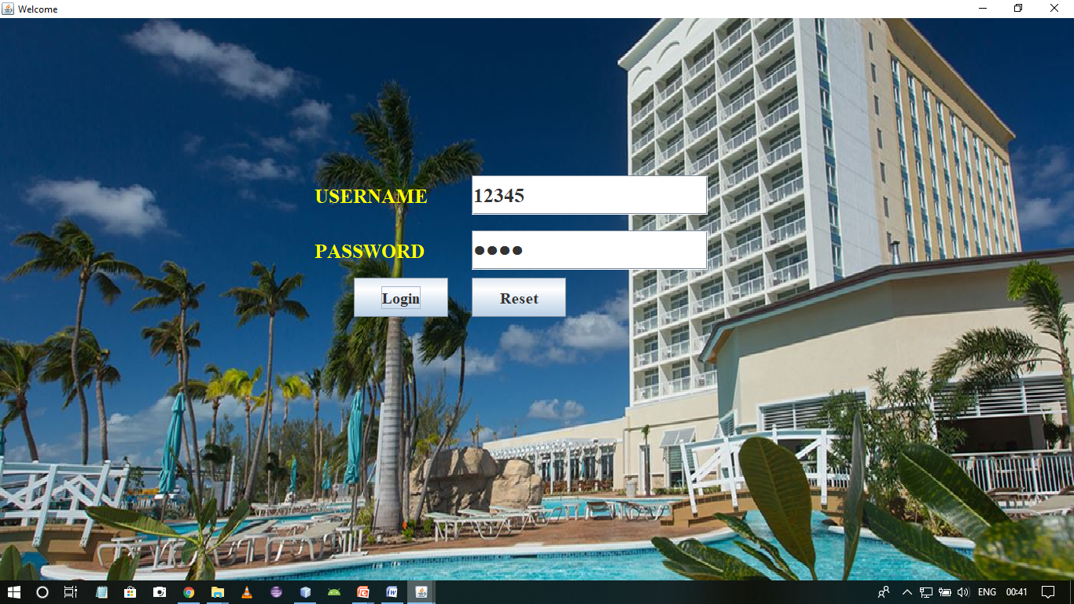

It is the login page for the receptionist who can login with the provided id and password.

**Error Message in Login Page**

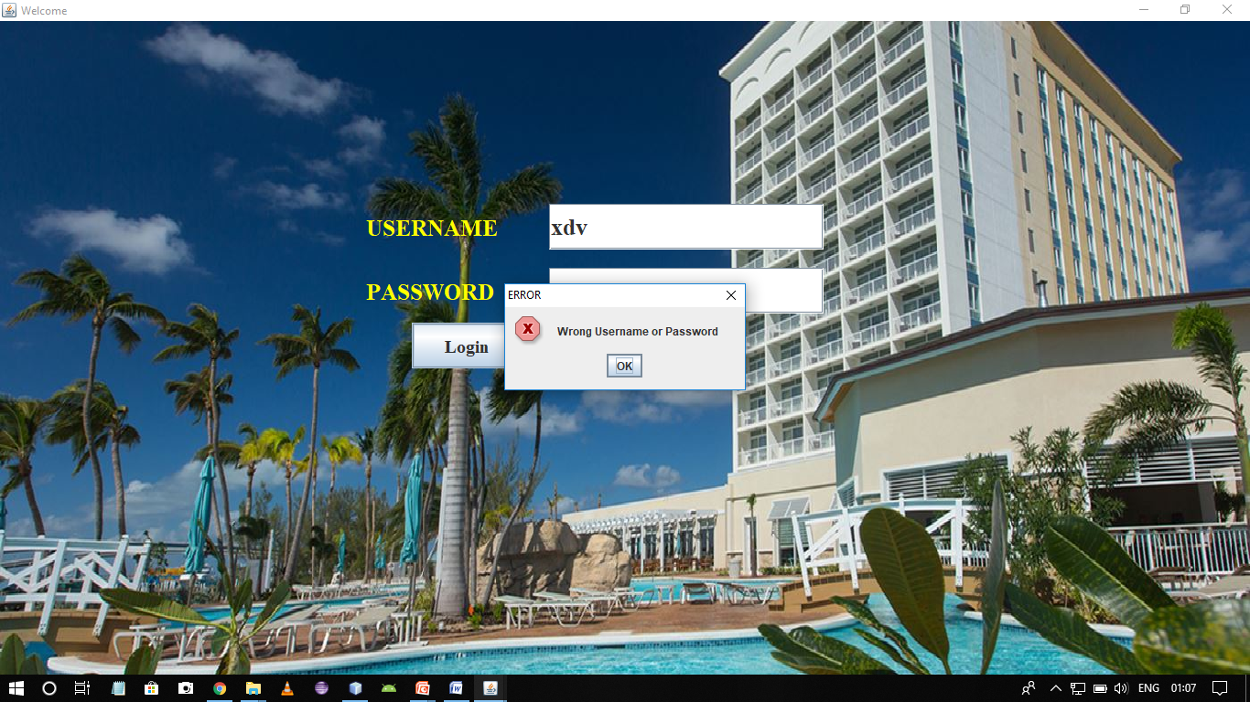

If someone enters the wrong username or password then it shows an error message on the screen.

**Hotel Menu**

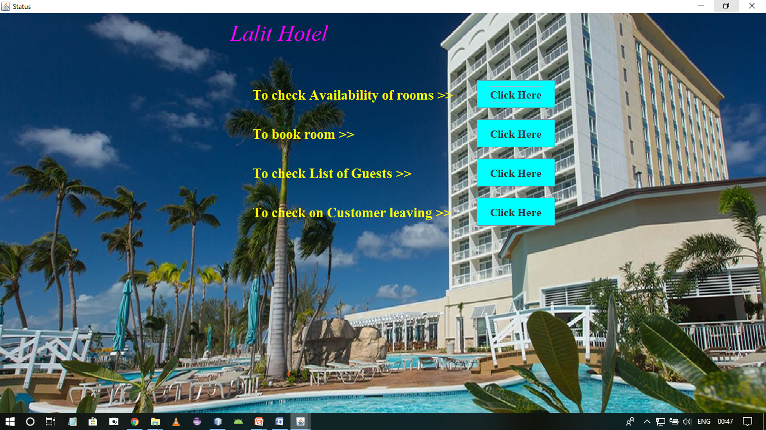

There are four things a receptionist can do. They are to check for availability of rooms, to fill the registration form, to check for the list of customers arrived and departed and to keep a check on the customers leaving.

**Status of Rooms**

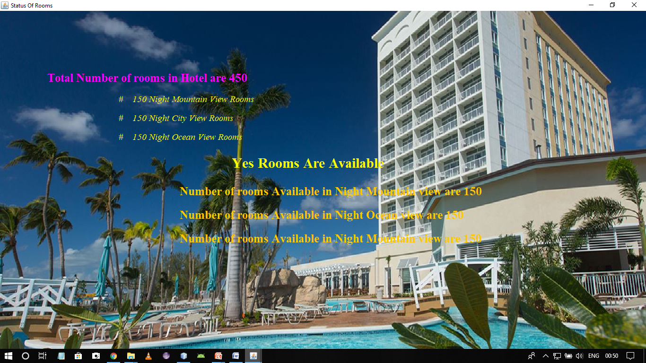

This frame gives status of the rooms i.e. how many rooms are available at present in the hotel and how many are vacant.

**Database of Hotel**

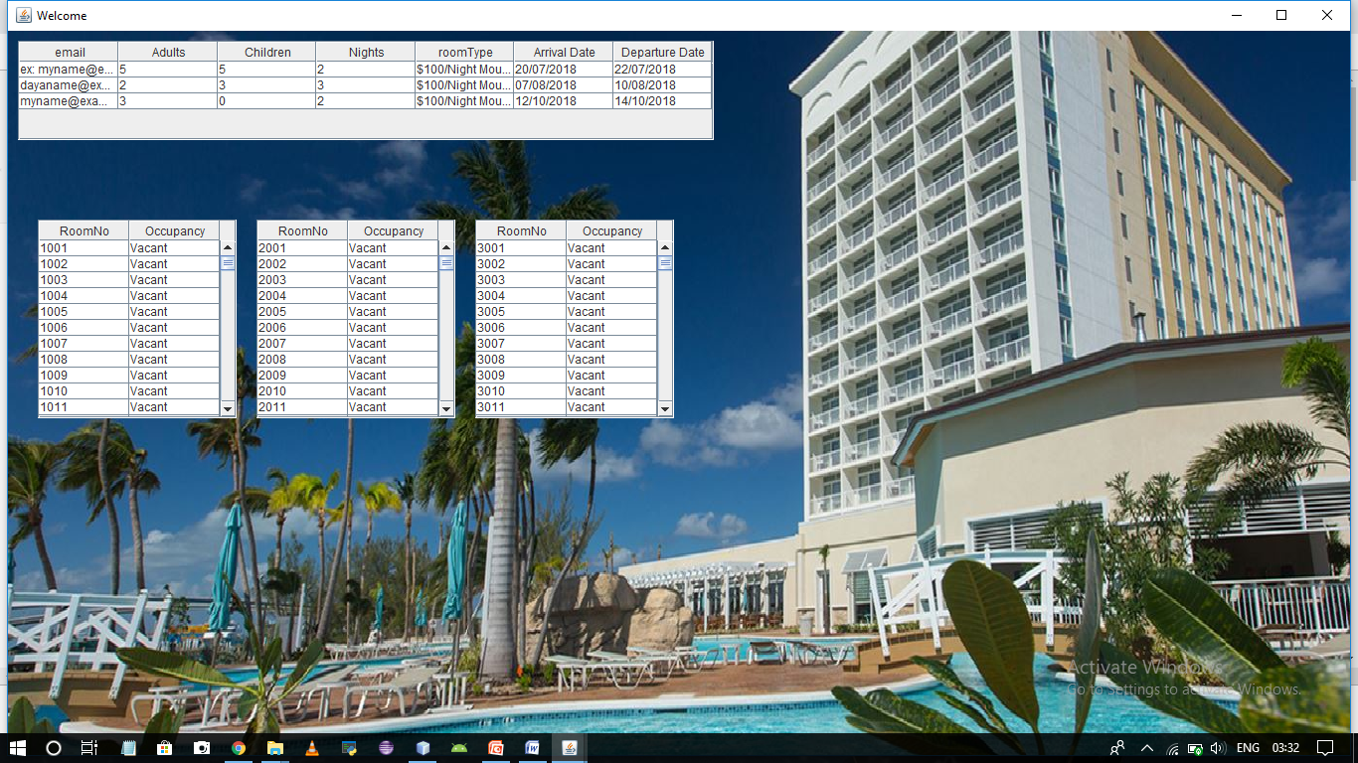

This page gives complete description of all the customers those who have stayed in the hotel and also checks for the Vacancy of the room(i.e. whether the rooms are empty or not).

**Vacating the Room**

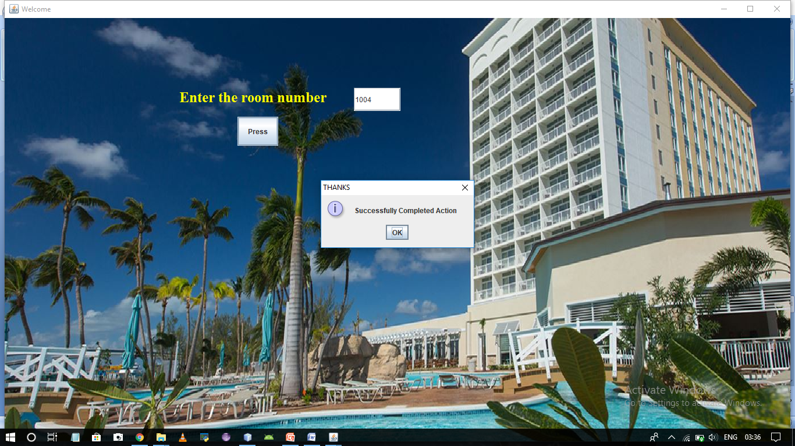

This frame keeps the check on the customers leaving. The rooms of the customers departing from the hotel are vacated by entering the room number.

The Status of the room in the database becomes vacant.

**Registration Form 1**

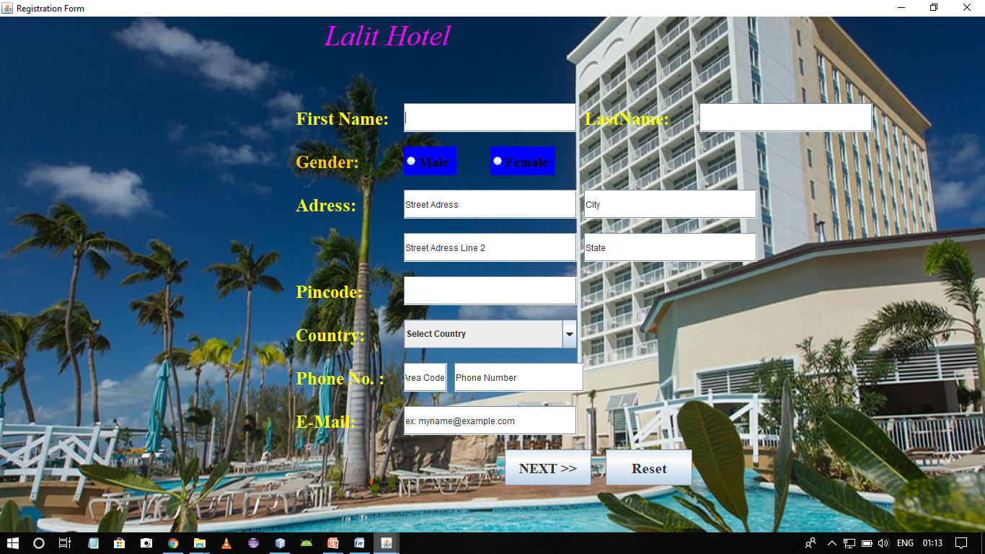

This frame shows the registration form for customer to be filled with the correct information.

**Registration Form 2**

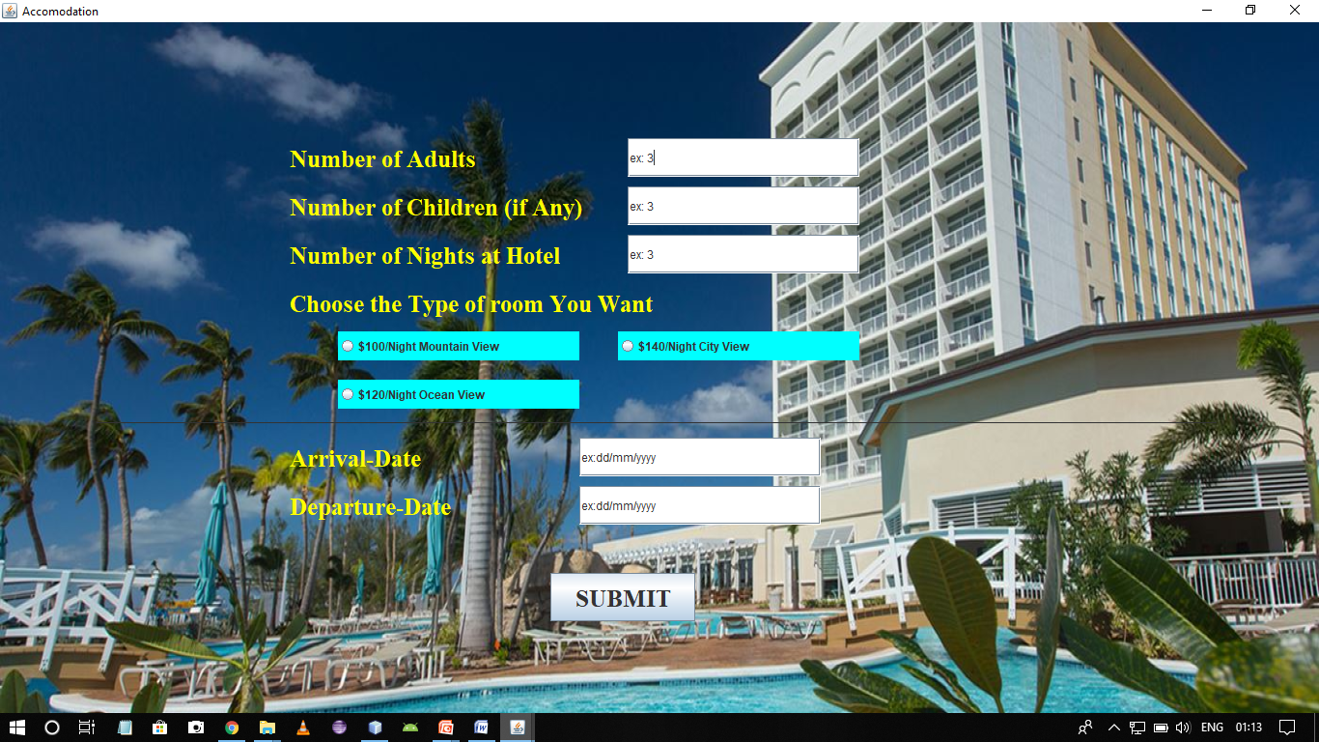

This form is also to be filled which asks for the desired type of room and for how many days the rooms are desired.

**Error Message in Registration Form**

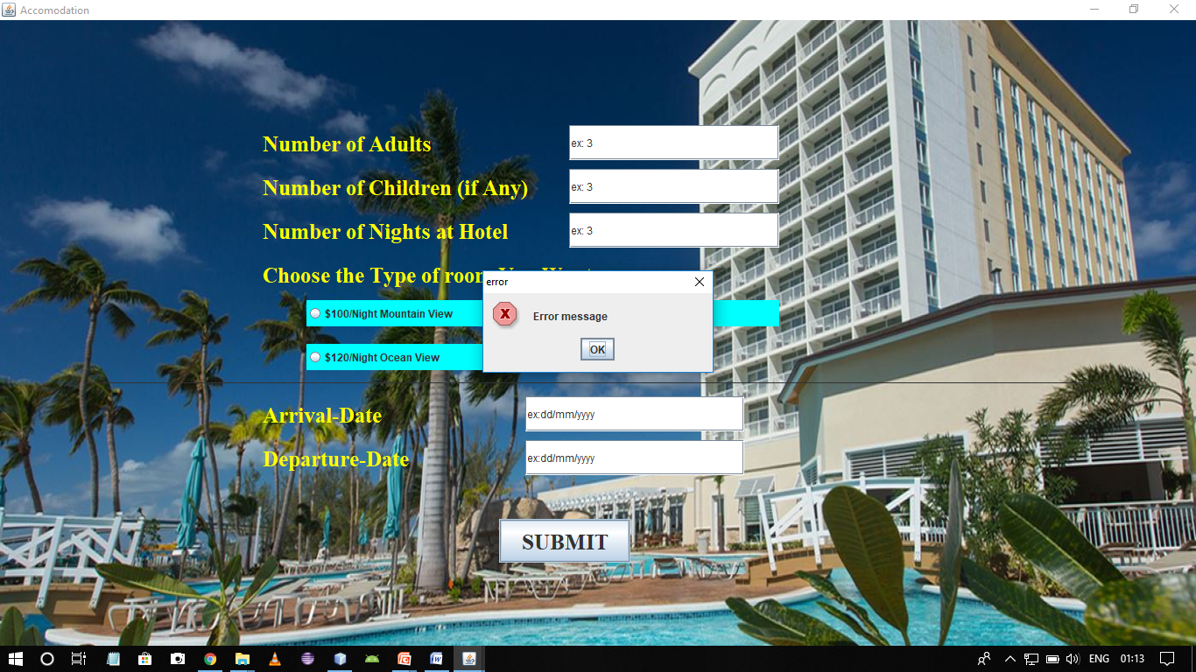

In this frame if any field is left empty then an error message is displayed.

**Payment of Hotel Room**

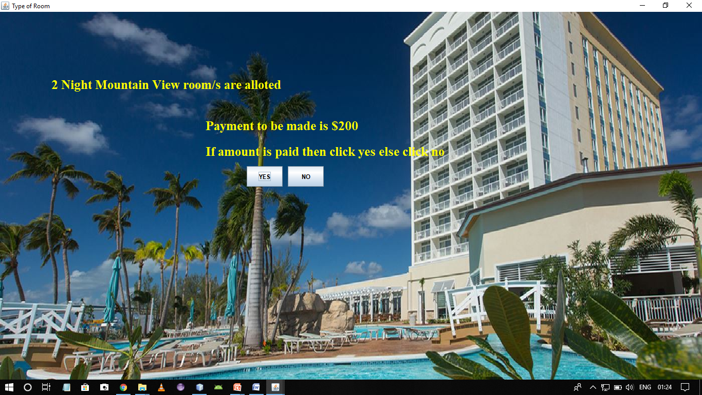

The Screen shows a message displaying the type of rooms desired by the customer and amount to be paid.

**Error in Room Allotment**

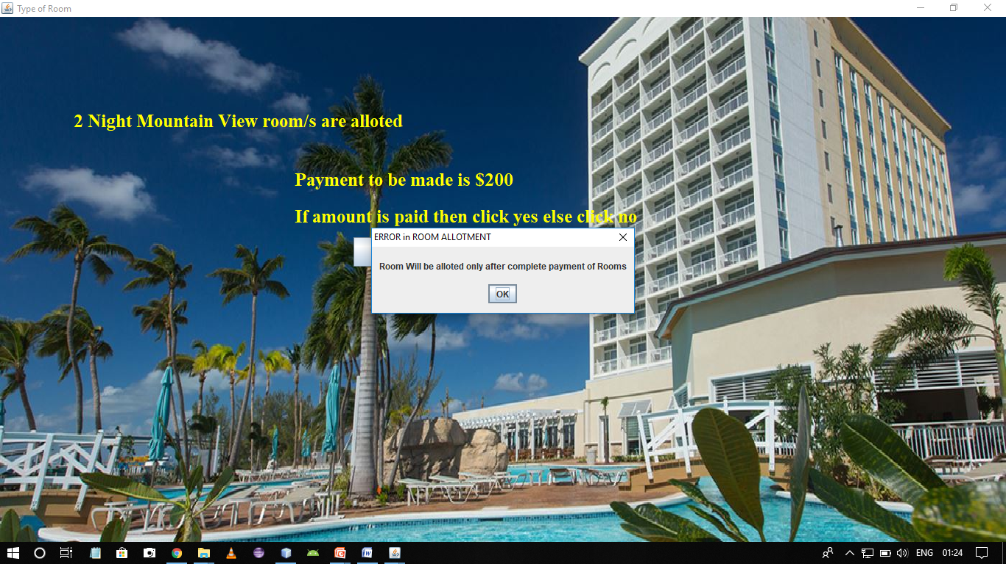

This Screen shows an error message due to payment

**Successful Room Allotment**

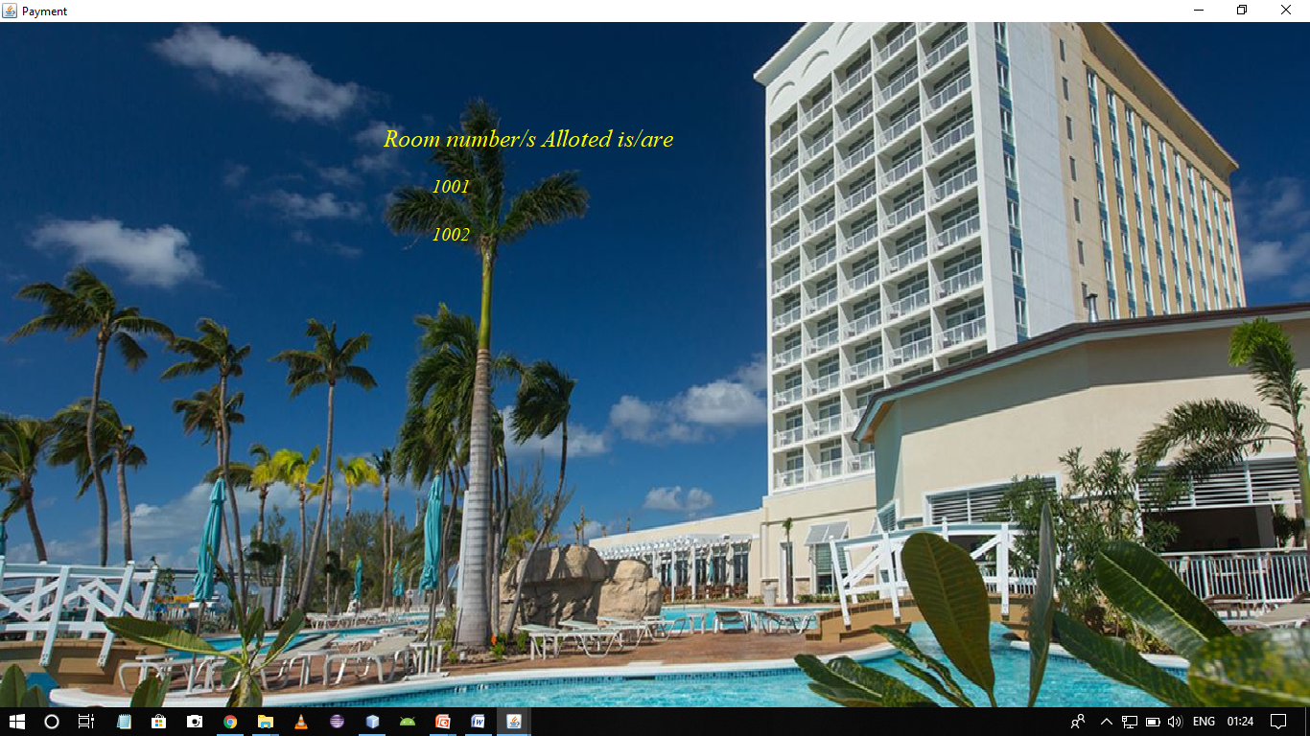

On this screen the room numbers allotted are displayed and room allotment is successfully completed.